# **What is Typography? - Definition, Terms & Examples**

## **What Is Typography?**

A good **typography** definition is the nuances in the style of text and characters in printed or otherwise distributed materials. Aside from being important in written works, it is also very important in the fields of art and communication in general. It has made a significant impact on the field of advertising as well. An example of typography is the distinctive form of typefaces used in publications from the Middle Ages in England using Old English. Although this distinct typeface was not used in every Old English publication, it has become synonymous with the Middle Ages (circa 400-1500 C.E.) and is called ''blackletter.'' Calligraphers often use this typography. Other typefaces used at the beginning of Western printing include ''roman'' and ''italic.'' A modern form of typography is the distinct typeface used by the original Macintosh computer, Chicago.

### **Typography Examples**

There are many examples of typography throughout the world and history. They are often used to give a distinct character to a product and impress certain ideas on the viewer. For example, the Chicago typeface was invented by a graphic designer specifically for Macintosh. Other examples of typography include:

* Comic Sans - This sans-serif typeface was created in 1994 by Microsoft. It was specifically meant to be easy to read, which is why it is used extensively by educators, especially for children.
* Helvetica - This typography was deliberately designed to impress. It was formulated in 1957 to draw interest to the International Style of type, also called the Swiss Style. Today, the New York subway system uses Helvetica exclusively for its signage.
* Papyrus - This typeface is made to mimic the stereotypical form of ancient texts and hieroglyphics.

## **History of Typography**

Typography's meaning dates to the first written word. There were three main typefaces at the beginning of Western writing: blackletter, roman, and italic. Each was used prominently by calligraphers, and when printing was invented, the print blocks were modeled after these extensively-used typefaces. Blackletter, the most commonly recognized of these typefaces, was created out of a desire to promote standardization of writing throughout the Carolingian empire. Blackletter was the typeface used to create Johannes Gutenberg's printed Bible, the first widely recognized successful printing effort in the Western world. A [cursive form](https://study.com/learn/lesson/cursive-handwriting-types-styles-examples.html) of blackletter became the official script of the rulers of many countries, while printed material gradually used blackletter less and less.

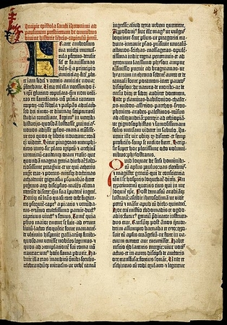

***The Gutenberg Bible was printed using a blackletter typeface by the printing press, which Johannes Gutenberg invented in the Western world.***

With the rise of humanists, who created a plethora of printed materials which they desired to spread throughout the population of their countries, blackletter fell out of favor, as the roman type was considered much easier to read. Today, blackletter is almost exclusively used for official documents and certificates and in newspaper headers, although this specific trend is becoming weaker.

Another significant invention was the creation of moveable type in 1041. This innovation enabled text to be arranged and reproduced easier. In 1440, the printing press was created by [Johannes Gutenberg](https://study.com/learn/lesson/johannes-gutenberg-inventions-facts.html), who used it to create his Bible. Design typefaces were introduced as printing machines became powered by steam during the Industrial Revolution (1760-1860), and it enabled more variation in typefaces used in advertising. The next advancement in typography came with the advent of the digital age. As mentioned above, Macintosh influenced the invention of Chicago, and as computers became more widely used and continued to become increasingly specialized, more and more typefaces were created for various uses.

## **Technical Terms in Typography**

The field of typography has many **technical terms**, including:

* Leading -This term refers to the different ways that text can be spaced vertically.
* Ascenders - The parts of letters that rise above the x-height, the line over which most lowercase letters do not rise.
* Descenders - These are letters that hang below the baseline of a text, such as ''q'' or ''y.''
* Kerning - This term refers specifically to the spacing between individual letters.
* Spacing - In typography, ''spacing'' refers to the spacing of words and paragraphs.

## **Elements of Typography**

The above techniques are used to create certain typographical elements in the text produced, including legibility, typeface, and typeface classification. Each of these elements is crucial for a useful typeface to be produced.

### **Legibility**

Legibility means that a text can easily be read and understood by a viewer because of the understandability of the individual characters. It is related to the readability of text, which has more facets than typography. Legibility is related to the concepts of letter spacing and line length.

Letter spacing is important in typography legibility because if letters are too close together, they will be jumbled and difficult to read. On the other hand, if they are too far apart, the reader's mind will treat them as discrete words, and it will be difficult to bring them together.

At first glance, line length might seem to be the purview of the text writer. However, kerning and letter spacing can influence the line length and the size of the text.

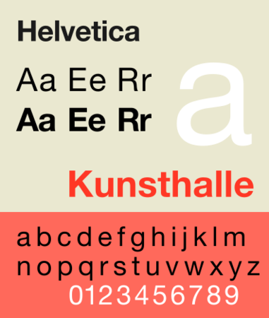

***This sample of Helvetica typeface shows how the differences in length, weight, and height can affect legibility and the message of the text.***

### **Typeface**

A **typeface** is mainly concerned with the appearance of a text. The major elements of a typeface are:

* Baseline - The baseline is the bottom line on which the texts rests. Descenders go below this line, but otherwise, no text should be below the baseline.
* Height
* Weight - Bold characters have more weight than non-bolded characters do. Adding weight to characters through bolding draws the reader's attention and emphasizes the context written in the bolded text.

### **Typeface Classification**

A **font** is a specific typeface designated as distinct from other typefaces. The five largest categories of fonts are:

* Serif - This term is derived from a Dutch term which means ''line,'' specifically a decorative line. These serifs are typically at the ends of letter stems and feet. Many people argue that serif typefaces are more readable than sans serif. Serif typefaces are usually used in reports and other documents with large amounts of text.
* Sans serif - ''Sans'' is a French word meaning ''without.'' Therefore, the term sans serif means ''without lines.'' Many people who use this font feel that serifs complicate the text. Sans serif texts are used in small blocks of text, such as signs or maps.
* Script - These are fonts meant to mimic a person's handwriting.
* Monospaced - These fonts are created so that the different characters written in the typeface are spaced equally, regardless of how large they are or if they are bolded or italicized. These are usually serif or sans serif fonts.
* Display fonts - These fonts are not standardized but are variable and created for their display value rather than being used in an extensively written document. For example, they are mostly used for advertising purposes or in the context of a book title.

Each of these fonts can be combined or manipulated in various ways to convey different meanings to the user aside from those explicitly stated by the text, much like body language can be used to enhance the understanding of listeners of the spoken word.